Keeping Maintenance professionals running Maintenance Departments
By Joel Levitt
There is a trend of having Accountants run maintenance departments. The logic is that experts in money and accounts can make the cuts that maintenance managers cannot. To some extent this is true; the accountants come to the maintenance department with a fresh vision and with fewer (and different) sacred cows. Their priorities are different and they don’t have the long term relationships to cloud their view. Maintenance managers may have become complacent or even resigned and there by ineffective.
Consider the difference between life time maintenance managers running a maintenance department versus accountants running a maintenance department. What is the difference of a money specialist running a maintenance department versus a maintenance specialist running a maintenance department? What would you expect?
You would expect that the money expert increase the efficiency, utility and effectiveness of the money assets. You would expect inventories to be cleaned up, cash to used more effectively, improved budget discipline and smarter use of banks, debt and equity. He or she would certainly be able to wrest a few (or even a lot of) dollars out of the operation. The value of this impact should not be minimized.
The accountant’s spread sheets with dollars spent, revenue, depreciation and hundreds of other items represent a model of the business. A good model is very useful and gives you power over the reality it represents. Let’s talk a little about models.
Didn’t you love the really good die cast automotive models when you were a child? The ones that the metal doors opened, the lights worked. When you opened the hood there was a real looking engine. Many children had their imagination stirred by good models. Girls had their own models. Girls loved dolls. They were pretty good models of babies, other girls or even grown-ups. While children loved their models there was no confusion in their mind that the model was not the real thing. Most children also realized (if they admitted it or not) that expertise with the model (such as with a baby doll) did not immediately qualify one with a real baby.
Merriam Webster gives us two definitions of the word model that apply to the relationship between the accounting for a business and the business itself. The first is “a description or analogy used to help visualize something (as an atom) that cannot be directly observed.” We use accounting models of the business to help us see how the business works. A business cannot be seen itself but we can manipulate the model and see what happens. One example is called a pro forma statement. According to Wikipedia in business, a pro forma document is one provided in advance of an actual transaction. Such a document serves as a model for the actual documents of the transaction. For example, when a new corporation is envisioned, its founders may prepare a business plan containing pro forma financial statements, such as projected cash flows and income statements
The second definition that seems to apply to accounting is a model is “a system of postulates, data, and inferences presented as a mathematical description of an entity or state of affairs; also : a computer simulation based on such a system.” In this case we use the relationships such as cost of goods sold to revenue to predict the effect of say changes in energy prices (vary the cost of goods sold by $X and see what happens to profit.
It is trivial to say but the most accurate model in the world is not the same as the real rubber and steel machine. Just like the most complete spread sheet with all the relationships is not the business. The second part of this might not be a nice thing to say but the best accounting in the world is crude when compared to the complexity of even a moderate sized business. The complexity of a large business is truly beyond comprehension.

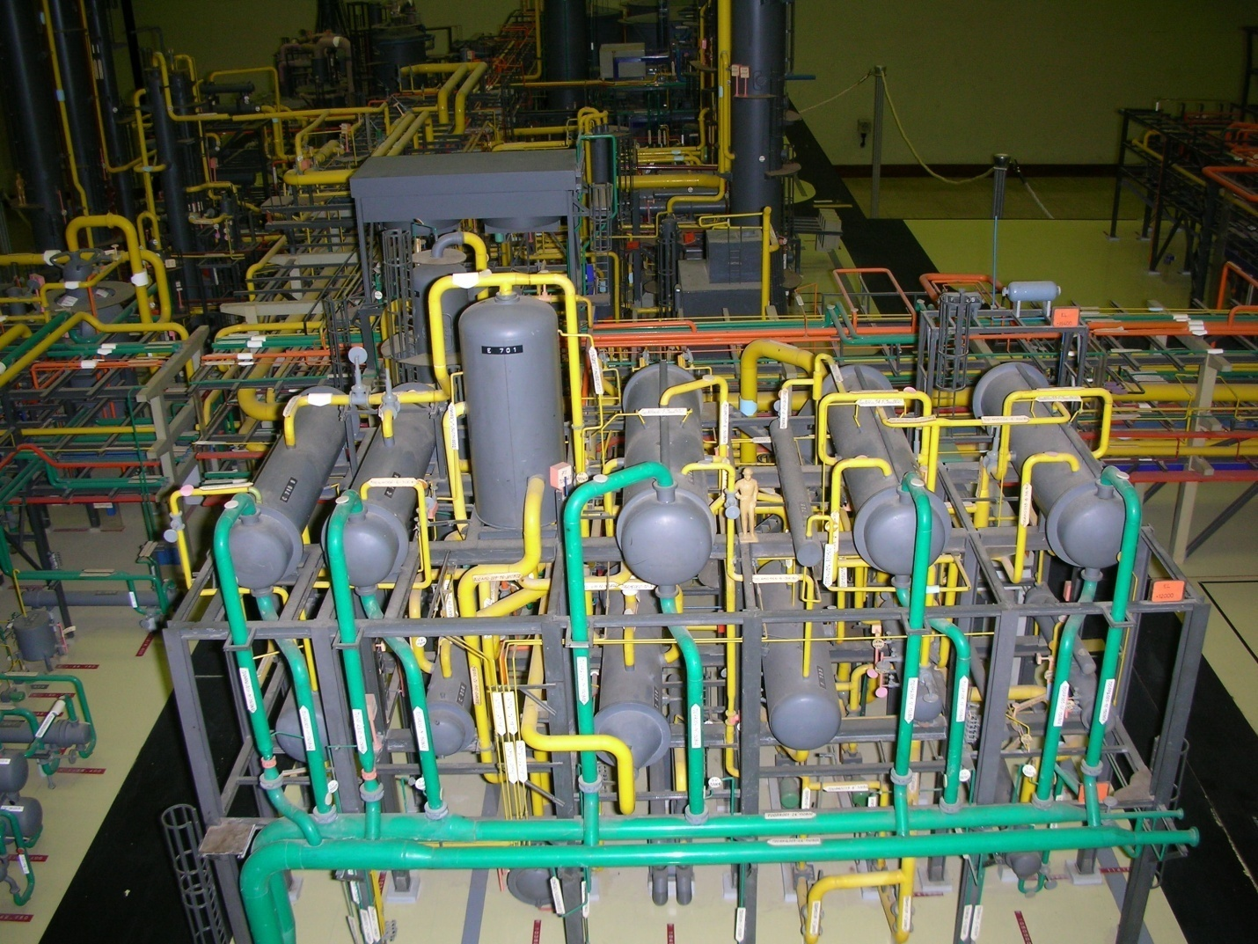
This picture is a model of an Ammonia plant. It is so accurate that if a scale sized pipe fit into the model the real thing would fit into the real plant. When the maintenance planning group starts discussing a shutdown they adjourn their meeting to the model room to see what the job will look like. Discussing the job and looking at the model is enormously useful. Accurate models are useful. Of course no one would think that Ammonia can be made from a model (although in the chemical industrial they do make model plants called pilot plants that make products) or that a model builder can run an Ammonia plant.
Accuracy is important in a model. If this model was inaccurate then the shutdown discussions would be based on faulty assumptions. Decisions based on faulty assumptions can be wasteful, dangerous or just plain stupid.
This relationship of the accuracy of the model and its usefulness is well known to the accounting profession. There are rules called GAAP (Generally Accepted Accounting Principles) to insure that accounting decisions represent the actual business being reported upon. Organizations spend millions to insure that the data is accurate so that decisions are based on real numbers. We are vitally concerned how we can impact the business when we sense that it is going the wrong direction and the model answer’s some of those questions.
Getting back to maintenance no accounting system can answer even relatively simple questions about maintenance. The answer to even a basic question like should this spare part be held in inventory even if it hasn’t been used for 5 years is beyond accounting systems.
As any maintenance manager knows the answer is related to the critically of the machine the part is used on, probability of failure, the kinds and effectiveness of PM and PdMs being done, the part availability and lead time, the cost of downtime, and even the condition of the industry (try getting tires for big haul trucks with the current mining boom). The accounting systems lack the data to help make these basic decisions. Few Accountants have the time or temperament to build the expertise to make these maintenance decisions themselves (without maintenance expertise as an input)
This is where hubris comes in. People may be ignorant of their ignorance and prideful about it. They argue something must be done and the model says cutting the inventory is the answer. The numbers on the spread sheet look better once the inventory is cut. Problem solved and score another victory for the system.
The problem is that the accounting system lacks the granularity to identify the consequence of that decision in terms of downtime, loss of productivity, loss of morale and loss of customer service. Without specific feedback the accounting profession cannot learn. In fact, the learners from these decisions are the maintenance professionals who have to still run the maintenance or business without parts. They are the ones that have to face the music 6 or 12 months later when the critical spare is needed and it is not available.
This is not to say that maintenance folks need to be given a blank check as far as maintenance. In fact the reason accountants come into the picture is because of the accounting ignorance of the majority of the maintenance profession. That ignorance results in excessive waste and lost efficiency in the maintenance effort which alerted the accountants in the first place. In this we need to step up to the plate and learn the language and how to look at and manipulate the models. The best decisions have both the maintenance knowledge and the accounting knowledge behind them.
